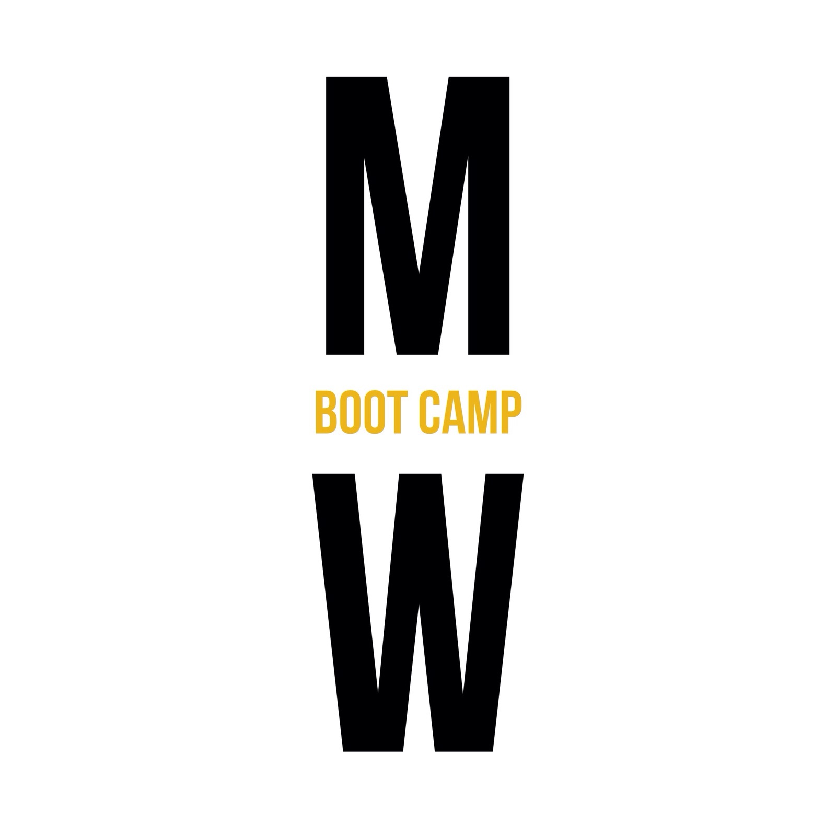
Feedback Form

Your Name (optional):

1. On a scale from 1-5 please rate your MW Boot Camp experience
1--poor
2--fair
3--good
4--great
5--excellent

2. Did you find the MW Boot Camp easy to follow?
Yes
Somewhat
No
If you answered no, please explain:

3. Why do you come to MW Boot Camp?

4. What are your fitness goals?

5. Please complete this statement: "I would add more _______ to MW Boot Camp"

Cardio
Strength training
Tools (bosu's, TRX, kettle bells, etc)
Core and flexibility
Nutrition info
None of the above, it was good the way it is
Other:

6. I found my coaches motivational and informative in these areas:
 | Poor | Fair | Good | Excellent
Exercise
Nutrition
Weight Loss/Gain
Time Management Skills

7. I found the best results from MW Boot Camps to be:
 | Poor | Fair | Good | Excellent
Weight Loss
Muscle/Strength Gain
Flexibility
Core Strength
Knowledge

8. Please feel free to comment on anything you like. All positive criticism is welcome as it is YOUR Boot Camp, and we want to make it the best for you!

Please help us help you! List up to 3 friends and their contact numbers and if one or all of them sign up you will be eligible for 1 month of Boot Camp FREE!

Thank you so very much for taking the time to complete our feedback form. It has been just awesome having you attend MW Boot Camps. We hope to see you at many more of our Boot Camps.

Cheers,
Mike, Adinda, Pipit, Andri

